**Pointer on pointer in go**

**A pointer to a pointer is a form of chain of pointers. Normally, a pointer contains the address of a variable. When we define a pointer to a pointer, the first pointer contains the address of the second pointer, which points to the location that contains the actual value as shown below.**

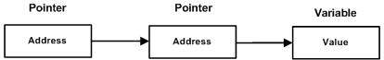

**package main**

**import "fmt"**

**func main() {**

**var a int = 10**

**var ptr *int**

**var pptr **int**

**ptr = &a**

**pptr = &ptr**

**fmt.Println(a)**

**fmt.Println(*ptr)**

**fmt.Println(**pptr)**

**}**

**10**

**10**

**10**